Name ________________________ Period _______ Date __________________
Threats to Biodiversity
Define biodiversity =
Why is having high biodiversity important?
Threats to Biodiversity (CHIPPO)
C-
H-
I-
P-
P-
O-
Climate Change
Changes in global ______________________ have made it too hot/too cold for some species all over the
world.
What is the difference between climate and weather?
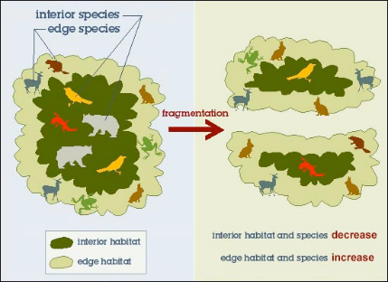
Habitat Loss and Fragmentation
Though to be the _______________ cause of loss of biodiversity.
Three ways humans cause habitat loss are….
1.

2.

3.

What is one reason habitat fragmentation is a problem for biodiversity

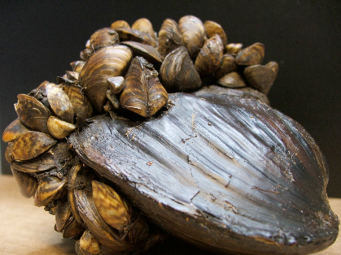
Introduced/Invasive Species
_________ greatest threat to biodiversity worldwide.
Define invasive species:
What are three ways that invasive species threaten biodiversity?
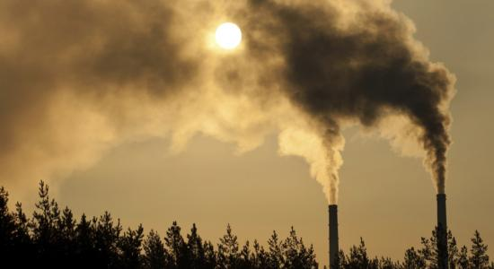
Pollution

Pollution is chemicals introduced into the ________. _________, or ______

Recall some examples of non-point source pollution:

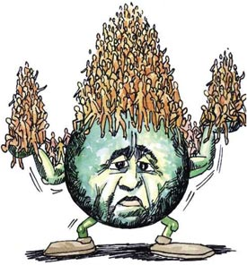
Population (of humans)

There are ~ _______ billion people on earth.
Human population growing at an _____________ rate
Have caused the other problems in ____________.
Why is having high biodiversity important?

Overexploitation/Overconsumption
By humans for ___________, _________________,_______________, _______________, etc.
Define overharvesting:

